THILINI BANDARA

Web Developer(Intern)

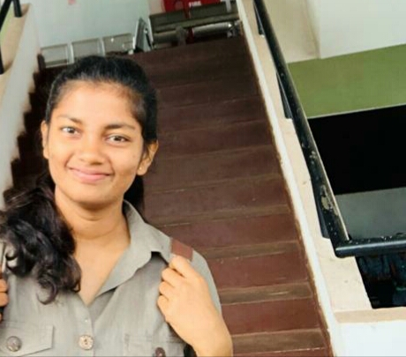

Personal Details

**Age:** 24

**Gender:** Female

Contact

**Address:**

Kottawita Waththa,Kabagamuwa,

Kegalle

**Phone:**

+94-71-0348535

**Email:**

[thilinidinushikabandara@gmail.com](mailto:dinithimweerasinghe95@gmail.com)

**Github:**

<https://github.com/ThiliniDBandara>

ABOUT ME

I’m a self-driven, self-motivated person who always work hard. I am very keen on working in an ever-changing dynamic, environment and self-motivated to take any challenge.

Projects

* Online quiz website (php, bootstrap, mysql) https://github.com/ThiliniDBandara/Online-Quiz-system
* Web system for applying research grant of sabaragamuwa university(laravel,bootstrap,Mysal) (Ongoing)
* Vehicle Management System(laravel,bootstrap,Mysql) (ongoing)
* Web applicatin for Daily Task (Laravel,bootstrap,mysql) <https://github.com/ThiliniDBandara/Daily-Task-App-Laravel>

Education

**BSc (Special) in Information systems**

Department of Computing and Information Systems Sabaragamuwa University of Sri Lanka.

**G.C.E Advanced Level Examination (2015 -Physical Stream**

Kegalu Balika Vidyalaya.

* Combined Maths - C
* Physics - C
* Chemistry - B

**G.C.E Ordinary Level Examination (2011)**

Ke/Hettimulla Nava Kanitu Viduhala

* 4 A
* 3 B
* 2 C

Certifications

PHP Framework (certificate): **Zend, Codeigniter, Symfony**.

Programming Languages: **JavaScript, HTML5, PHP OOP, CSS, SQL, MySQL**.

Interests

* Blogging
* Participating for Meetups
* Travelling
* Gaming

Technical skills

**Languages:**

* HTML5,CSS3
* PHP
* Java Script
* C

**Frameworks:**

* Laravel
* Angular
* Bootstrap

**Tools:**

* MySQL
* Visual Studio Codes
* NetBeans
* git

Personal Skills

* Team work
* Leadership
* Management
* Communication Skills
* Creativity

Soft skills

* Ability to adapt to challenging situations and overcome those situations.
* Excellent fluency in English and Sinhala.

Achievements

* Participated Code Night Hackothon 2018 conducted by Depatment of Computing and Information systems, SUSL.
* Participated Women’s Day 2019 organized by WTM.
* Volunteered for LetMeHack 2018, SUSL.

Extra-Curricular Activities

* Organizing Committee member of Virtual Rival Gaming Encounter.
* Organizing Committee member of Code Night Hackothon 2019.
* Member of Media subcommittee at Sabaragamuwa university of Sri Lanka.

Course Highlights

* Web Development (front-end / Back-end)
* Advanced Database system
* Agile software Development
* Enterprise architecture

Referees

**Mr. Kalinga Gunawardhana,**

Lecture (Prob.),

Department of Computing and Information Systems,

Faculty of applied Sciences,

Sabaragamuwa University of Sri Lanka.

**Email:** [kalinga@appsc.sab.ac.lk](mailto:kalinga@appsc.sab.ac.lk)

**Mobile:** +94771868212

**Dr. B.T.G.S Kumara,**

Head/Dept. of Computing and information Systems,

Senior Lecture in Faculty of Applied sciences,

Sabaragamuwa University of Sri Lanka.

**Email:** [kumara @appsc.sab.ac.lk](mailto:ravindra.dangalle@appsc.sab.ac.lk)

**Mobile:** +94711682109

***I hereby declare the above mentioned particulars are correct and true to the best of my knowledge.***

Certifications

PHP Framework (certificate): **Zend, Codeigniter, Symfony**.

Programming Languages: **JavaScript, HTML5, PHP OOP, CSS, SQL, MySQL**.